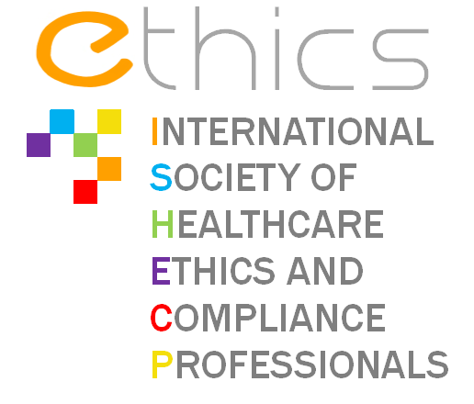
Guidelines Governing ETHICS Meetings

ETHICS – International Society of Healthcare Ethics and Compliance Professionals (hereinafter "ETHICS or the Association"), is an Association Law of 1901, registered with the Prefecture of Paris under number W751213412, whose head office is located at 1 rue d 'Astorg, 75008 Paris, France.
Latest update: January 2013

ETHICS' MISSION
ETHICS’ activities will develop around the four following pillars: communication, professional development, think tank and sharing of experience and best practices, sustained by one transverse and permanent objective: support professionals in compliance and ethics in healthcare industry to develop and better manage their role and duties – without any sort of commercial benefit for the Association or any of its members.
The activities of the Association shall extend to all matters of common interest to its members.
GUIDELINES
When competitors meet to discuss policy issues relating to their business, there is a risk that competition rules are infringed. Courts in the US and in Europe recognise that associations can play a legitimate role in formulating public policy positions relevant to the sector, but there are boundaries to what is permissible. Commercial strategies re particular policy areas cannot be discussed.
These guidelines are designed to ensure that in organizing / attending meetings at which competing companies are present, ETHICS avoids engaging in facilitating any discussion or activity, which might violate the competition laws of the European Union (EU).
Strict compliance with these rules is especially important; not only will participating companies be responsible for any anti-competitive conduct, but industry associations can also be held liable.
BEST PRACTICE
- All meetings organised / attended by ETHICS must have a legitimate purpose.
- For all meetings organised /attended by ETHICS there must be a written agenda circulated in advance of the meeting. --1FR-- 79510 3 12763 v0.22000 04
- When written minutes of a meeting organised by ETHICS are established, they will be submitted for approval to participants.
- Membership of working groups / participation criteria to meetings must be transparent and non-discriminatory.
- In case of doubt as to the legitimacy of a discussion, an ETHICS representative must ask to stop the discussion until the appropriateness of the topic / discussion can be confirmed.
These guidelines apply to all ETHICS meetings, including meetings of statutory and decision-making bodies, specialised groups' meetings, policy committees, project action teams, task forces, ad hoc groups, and any other working group.
PROHIBITED CONDUCT
Any form of express or tacit collusion amongst competitors aimed at directly or indirectly influencing prices or allocating customers or geographic territories is viewed as an extremely serious offence and will attract hefty fines if uncovered.
The competition rules strictly prohibit any discussion, understanding or agreement between competitors, however informal, or the exchange of information on:
- individual company prices, price changes, pricing strategies, terms of sales, price mark-ups, discounts, allowances, credit terms
- costs of production or distribution, cost accounting formulae, methods of computing costs
- individual company figures on or plans as to sources of supply, production, inventories, sales, marketing and promotion
- any matters relating to individual suppliers or customers, including any attempted collective action that might have the effect of excluding suppliers or customers from the market
- information as to future plans of individual companies concerning technology, investments
WHAT MAY BE DISCUSSED AT MEETINGS
- non-confidential, technical issues relevant to the industry, such as standards, environmental concerns, matters related to corporate social responsibility, health and safety matters, regulatory policy developments
- publicly available information on market trends general promotional opportunities (but not a particular company's promotional plans)
- industry public relations or advocacy activities ---- 2FR-- 79510 3 12763 v0.2 2000 04
GUIDELINES ON INFORMATION EXCHANGE
The exchange of statistical information is permitted when it:
- is general, historical and non-confidential, or comprises aggregated data of at least 3 independent producers (zero or negligible inputs must be excluded when they might cause the disclosure of individual companies' data); and
- does not enable the identification of individual businesses, or is processed by an independent third party to ensure confidentiality
Is however prohibited, the exchange of confidential and company-specific information between competitors, such as data on:
- prices
- output
- capacity utilization rates
- costs
- sales volumes
- market shares
- marketing plans
- inventory.

